LABORATORY EXPERIMENT TESTS
AGTI (SEMESTER 5)
Web Development Technology Using PHP
(IT-DP 3508)
SR. | JOBS | DATE | MARK GIVEN | MARK GOT
1. | JOB 2 : Electricity Bill Calculator
OBJECTIVES
- Calculate electricity consumption based on units used
- Generate corresponding electricity bill

Total

Student Name: Ma Shar Thet Han | Teacher Name:Daw Aye Aye Mu
Roll Number:3GIT-8 | Designation:
Sign: | Sign:

JOB 2 : Electricity bill calculator
OBJECTIVES : Calculate electricity consumption based on units used
: Generate corresponding electricity bill
Question : Write a PHP program to calculate electricity bill using if…else conditions.
Conditions:
- For first 50 units are billed at 50Ks/unit
- For next 50 units (51 to 100) are billed at 100Ks/unit
- For next 100 units (101 to 200) are billed at 150Ks/unit
- For any units above 200 are billed at 300Ks/unit
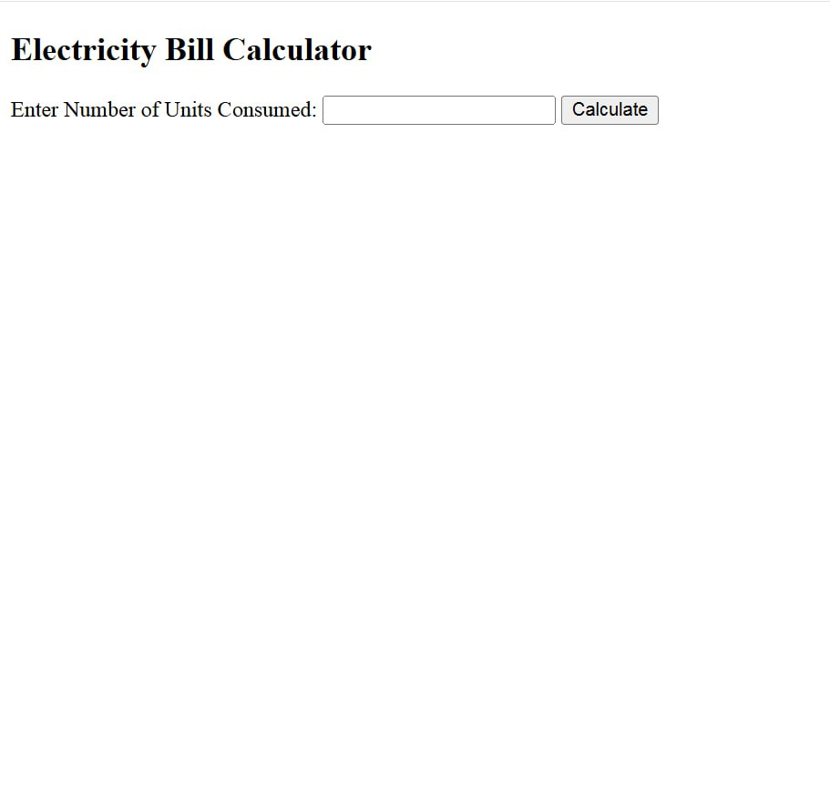
.

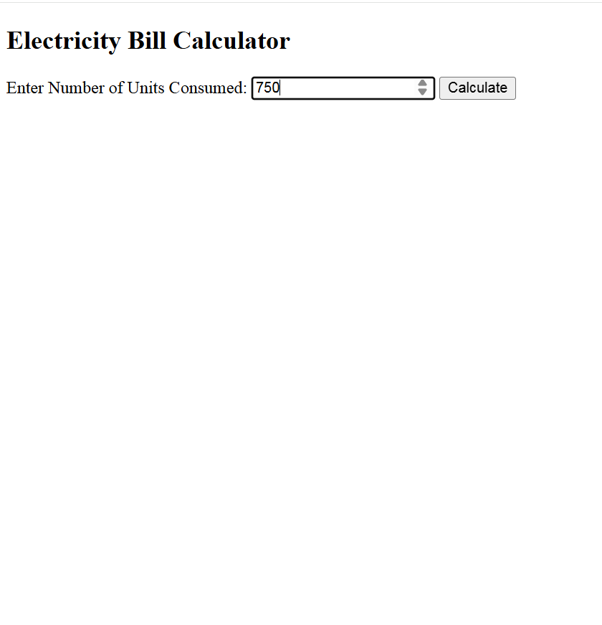

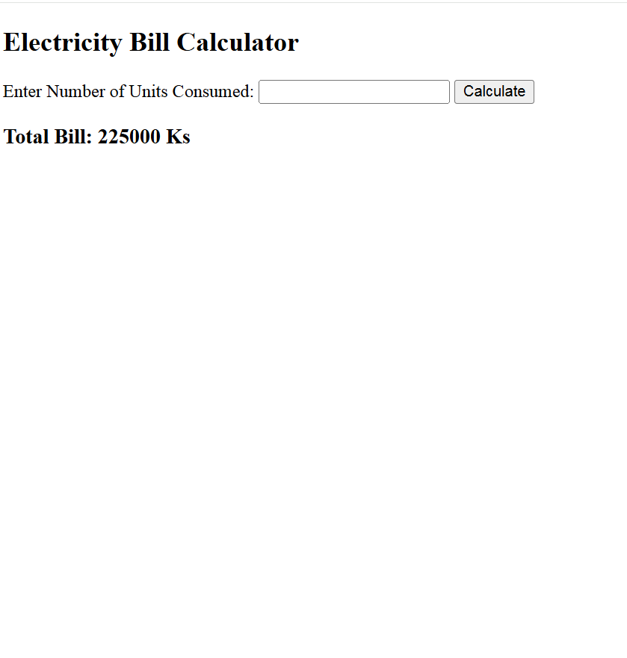

Coding:
<!DOCTYPE html>
<html lang="en">
<head>
<title>Calculate Electricity Bill</title>
</head>
<body>
<h2>Electricity Bill Calculator</h2>
<form method="post" action="">
<label for="units">Enter Number of Units Consumed:</label>
<input type="number" name="units" id="units" required>
<input type="submit" name="submit" value="Calculate">
</form>
<?php
if (isset($_POST['submit'])) {
$units = $_POST['units'];
$bill = 0;
if ($units <= 50) {
$bill = $units * 50;
} else if($units > 50 && $units <= 100) {
$bill = $units* 100;
} else if($units > 100 && $units <= 200) {
$bill = $units* 150;
} else {
$bill = $units* 300;
}
echo "<h3>Total Bill: $bill Ks</h3>";
}
?>
</body>
</html>

